Collective underlines public discussion as key to better future
0
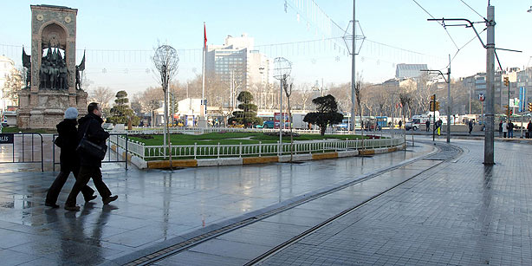
(Photo: AA)
9 May 2012 / LATİFA AKAY, İSTANBUL
Wednesday morning saw the Taksim Platform group gather in İstanbul’s leafy Gezi Park to air its latest concerns regarding the impending “Taksim Project,” a controversial municipal initiative to remodel Turkey’s most symbolic square.
An intimate meeting led by high-profile members of the collective, including renowned author Murat Belge, architects Oğuz Ayata and Korhan Gümüş, academics Betül Tanbay and Mine Özerden and French Institute of Anatolian Studies (IFEA) head Nora Şeni, the group, made up of concerned citizens from all walks of life, reiterated its demands for city officials to serve their constituents in a more transparent way.
The Taksim Project calls not only for the construction of enormous ramps leading to subterranean tunnels at various points in the vicinity of the symbolic square, but also the transformation of the historic area into a concrete, pedestrian-only zone and more perplexingly, the replacement of Gezi Park with a reconstruction of the an Ottoman military barracks that was demolished in 1940.
Tanbay told the press that the failure of the İstanbul Committee for the Protection of Cultural and Natural Assets to recognize the importance of protecting Taksim Square as a whole undermines the body’s own constitution. The committee has been assessing the issue of the construction of tunnels and the future of Gezi Park as two separate matters, an evaluation Tanbay deems to be “scandalous.”
Commenting on the projects’ latest developments Tanbay told Today’s Zaman that while İstanbul Mayor Kadir Topbaş recently made a statement to the effect that only one tunnel would be built for the time being that this is not a satisfactory response to the group’s demands. “If there is only to be one tunnel, that means there must be a completely new set of proposals, plans and decisions -- we have yet to see any of this,” Tanbay said, reiterating the platform’s line that public discussion and transparency are the key to successful urban gentrification.
Speaking in an interview with Today’s Zaman, author Belge said the whole methodology of the project is wrong. “Can you imagine a mayor of London planning to build tunnels under Trafalgar Square without consulting anyone? In many ways the arbitrary methods used by the İstanbul Municipality are more dangerous than the project itself because if the initiative goes ahead, it means that really they can do anything,” Belge said, underlining the fact that the platform is simply inviting the government to be more open to debate and criticism. “We are not Serbs and Croats. We can talk openly with each other,” he added.
Historian and urban planner Şeni said the procedure of consultation, a principle inscribed in Turkish law, has been completely disregarded by the Taksim Project. “The fact that the government received 50 percent of the public vote has effectively been used as a demonstration of the legitimacy of the project,” Şeni told Today’s Zaman. Architect Ayata added dryly that the types of issues the Turkish public gets consulted over are trivialities such as the color of municipality buses.
Ayata listed the annual rally on May 1, Turkey’s Labor Day, attended by tens of thousands of Turkish citizens, the screening of important football matches and the erection of tents for the communal breaking of the fast during the holy month of Ramadan as examples of public activities that would be disrupted if the Taksim Project goes ahead in its current form. While Şeni remains optimistic that the project will ultimately be suppressed and replaced with a more sustainable and practical venture, Belge is less certain.
“We have reached a point where I have braced myself to watch the erection of this replica military barracks with tears in my eyes. But our struggle will go on,” he said.
To follow the activities of the Taksim Platform, see http://www.taksimplatformu.org/.

