http://www.schoolvoorjournalistiek.com/europeanculture/?p=7951

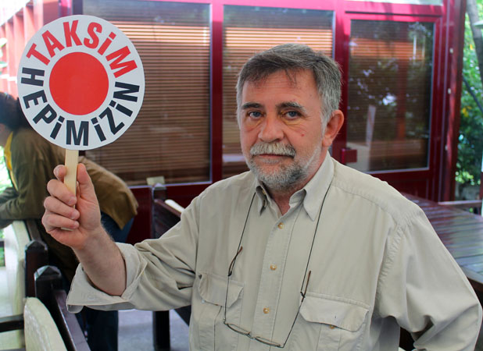
Members of the Taksim Platform seek to halt massive construction plans in downtown Istanbul

Contested Municipal Plans to Drastically Renovate City’s Largest Square
ISTANBUL – It’s a muggy Monday afternoon in Beyoğlu, Istanbul’s central district, as people walk quietly past the entrance of a chic Turkish restaurant and head to a room at the height of a long flight of narrow white steps.
“It’s small tonight, but usually there’s more,” whispers Betül Tanbay, smiling as she turns to face a group of casually dressed Turks, sitting and talking quietly amongst themselves in a circle.
Those in attendance speak hurriedly in Turkish, reading notes or sipping tea from an old aluminum percolator in the hallway. A communal silence covers the room and the meeting begins. Tanbay stands and begins reading aloud from a notebook.
This is the Taksim Platform, a group of Istanbulites who have met nearly every week for several months to discuss halting municipal plans that would drastically change one of the city’s largest public meeting place, Taksim Square.
The plans have been marred from the start by public accusations that the decision making process lacked transparency and basic democratic consultation.
Historically and culturally, Taksim Square is Istanbul’s beating heart, the centre of the city’s European side; a hub for tourists, shops, bars and trendy cafés.
İstiklal Avenue, the city’s main shopping artery, winds downhill from the square to the Bosphorus Strait, navigable by foot or a single rustic tramcar that looks almost superimposed from a tacky San Francisco postcard.
The Monument of the Republic stands at the centre of the square, paying homage to the formation of the Republic of Turkey following the Turkish War of Independence in 1923.
But in 2011, the Municipality of Metropolitan Istanbul announced major renovation plans that would see a complete transformation Taksim square and the surrounding area.
The proposed “Taksim Plan” would see the construction of enormous ramps leading to subterranean tunnels directing all vehicle traffic under the square. The ramps, 10 meters deep and 100 meters long, will be located at seven points near the square.
High concrete walls will be erected, and the existing sidewalks along the boulevards will be transformed into service roads.
Additionally, plans call for the reconstruction of the Taksim Military Barracks, a massive Ottoman complex that once stood at the site before being demolished in 1940. The reconstructed barracks would now likely serve as a shopping mall or commercial area.
In February 2012, the municipality released a short, digitally animated video that takes viewers into the new square and even along for a drive through the subterranean traffic lanes.
The plans boast that by relaying all motorized movement under the square and making Taksim entirely pedestrian, everyday problems of density and crowding will be resolved.
However, according to the Taksim Platform, the announcement came as a shock to residents. A manifesto published on their website outlines how the plan violates the basic nature of participatory democracy.
“Despite being a public initiative financed by city taxes, residents of the city and civic organizations have not been informed of, nor consulted about, the details of the project,” it reads. The group claims that the No. 2 Regional Agency for the Preservation of Cultural Heritage Sites “passed the bill with speed unprecedented for a ‘reconstruction project.’ ”
Members also claim that instead of easing pedestrian traffic in the square, the plan will simply make the area harder to reach by foot.
“It is a project of making the place pedestrian, but the result will be the total inverse. The tunnels take away the cars, but now you can’t cross the street to get to the square,” says university professor and Taksim Platform member Nora Seni. “The video is absurd, it is disinformation!”
“As architects and urban planners, we want the possibility to discuss what is happening in our city,” says architect Sinan Omacan.
Another point of dispute is the Taksim Plan’s first and most notable casualty, Gezi Park, a fountain studded, large urban green space adjacent to the square. The park, constructed in 1940 after the barracks were destroyed, is a popular relaxation and picnic spot for Istanbulites, a neat green splash quietly buried in the city’s bustling downtown core.
“We thought at first it was just pre-election talk, but when we saw the red ‘X’ marks on the trees one day, we knew this was real,” says Tanbay.
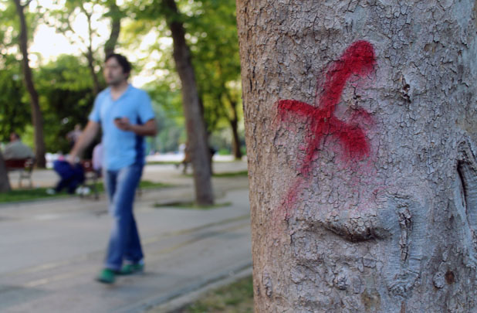
It is still unclear exactly when Gezi Park’s trees will be cut down
The square, along with the adjacent İstiklal Avenue, are also the scenes of near-daily protests and marches from labour unions as well civilian, student and right-wing activist groups. The area was also the site of the 1970 Taksim Square Massacre, when several political groups clashed leaving 34 dead and many others injured.
On May 1 2012, International Worker’s Day, hundreds of thousands gathered in the square and marched down Istiklal waiving red flags and banners.
The square’s history as a meeting place for the politically disenfranchised has left some residents to wonder if the proposed plans have a secondary motive.
“To me, it seems like they’re trying to kill spaces where people meet, drink, smoke and discuss,” says Istanbul resident Damla Açikada. “It just doesn’t make sense. It’s so at odds with the artistic shift in the city.”
Although representatives from the municipality of Istanbul originally agreed to speak on record about the project, they have since been completely unavailable for comment.
Tanbay says the lack of response from the municipality is normal and indicative of the political climate in Turkey. She also maintains that this attitude goes hand-in-hand with the lack of media attention being paid to the issue.
“There’s no real journalism in Turkey, they never ask the right questions, they just follow whatever the government does and agree with it,” says Seni. “Most have no interest in this [issue].”
Several months ago, the Taksim Platform first began gathering signatures for a city-wide petition against the reconstruction. The petition received nearly 15,000 signatures in 15 days.
Yet, in that time, Tanbay claims their website was hacked twice by anonymous tricksters. The second time, instead of displaying their information and petition, for a few hours their URL directed instead to the municipality of Istanbul’s website.
“We couldn’t believe it! We wanted to take a picture because we knew no one would even believe us!” Tanbay says. She says that although they can never prove who was behind the hacking, they have their suspicions.
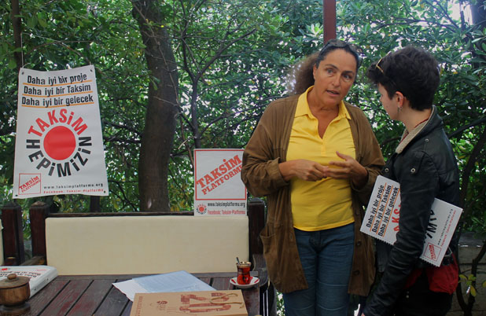
Tanbay and the Taksim Platform have been working for months to establish lines of communication with city planners
On a Wednesday afternoon, members of the Taksim Platform sit at a quiet tea house buried in Gezi Park. Along nearby paths couples walk hand-in-hand past an old man playing the bağlama, a traditional Turkish folk instrument. The tree he is leaning against is marked with a cherry red “X.”
Group members sip chai tea and begin passing out pamphlets and hanging red signs on nearby trees.
“We have one question. Why Taksim and why do the authorities feel that they don’t need to consult anyone when they make plans?” Ozerden says. “It’s a simple question and we need an answer.”
As people start to leave the meeting, a waiter quietly slips a handwritten bill upside-down on the table. Several members reach instinctively for their purses and pockets, then smile quickly when their eyes meet over the table. To date, Tanbay says all of the Taksim Platform’s efforts have been funded by the members themselves.
One of the lunch’s guest speakers is Murat Belge, a prominent Turkish intellectual, academic, translator, literary critic, columnist, and civil rights activist. Tanbay introduces him as “Turkey’s Renaissance Man.”
“I’m used to seeing political authority in Turkey, so I’m prepared to watch with tears this Taksim Barracks getting erected. But the struggle for other things will go on and it’s an accumulation of awareness,” Belge says. “The struggle has to go on.”
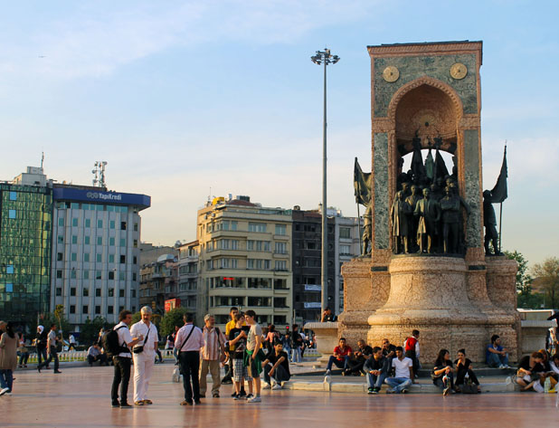The square acts as a meeting place for thousands daily

